Software Design Specification (SDS)
AI-Native Retrieval Engine for Agentic Workflows
Version 1.1 · 4 October 2026
This SDS describes how the engine meets every requirement in the companion SRS: a layered, interface-driven Python service whose controlled path is a LangGraph loop over an explicit retrieval state, with a deterministic utility-based controller. It follows IEEE 1016 (software design descriptions). Every design element traces to SRS requirement IDs in Section 10.

Document control
Field | Value
Project | AI-Native Retrieval Engine for Agentic Workflows
Programme | BS (CS), FAST School of Computing, FAST-NUCES Karachi, Fall 2026
Team | Samay Kumar (23K-0620), Vishal Kothari (23K-0040), Kabir Raj (23K-0702)
Supervisor | Zulfiqar Ali Memon
Companion document | SRS v1.1, 4 Oct 2026

Version | Date | Author | Change
1.0 | 26 Sep 2026 | Project team | Initial SDS
1.1 | 4 Oct 2026 | Project team | Windows-only deployment; supervisor and approval signatures; aligned with ADR-009; API limits from config (ADR-010); deviations recorded (ADR-011); NDCG@k added; owners per proposal Table II

Approval | Name | Signature | Date
Supervisor | Zulfiqar Ali Memon | Zulfiqar
Group members | Samay Kumar, Vishal Kothari, Kabir Raj | Samay, Vishal, Kabir

1. Introduction

1.1 Purpose and audience
The SDS is the blueprint the team implements and the evaluators assess. It fixes component boundaries, data structures, algorithms and interfaces precisely enough that each module can be built and tested independently.

1.2 Scope
The design covers the engine service, its controlled and direct paths, the Qdrant retrieval backend adapter, the LLM client, persistence, the evaluation subsystem (baselines, harness, metrics, statistics) and the external agent demo. Final answer generation inside host applications is outside the design, except the shared generator used for evaluation.

1.3 Design goals
ID | Goal | Driven by
DG-1 | Pluggability: the host keeps its retriever and generator; the engine wraps an adapter | FR3, FR11, NFR-M1
DG-2 | Fair measurability: every compared system shares one index, embedder, reranker and generator | FR10, VR-1
DG-3 | Transparency: every decision is deterministic and logged with its inputs | FR6, NFR-O1
DG-4 | Boundedness: planning, retries, steps, calls and cost are capped | FR4, FR8, NFR-P4/P5
DG-5 | Reproducibility: runs are fully described by config, commit and data hashes | NFR-X1–X4
DG-6 | Simplicity: synchronous code a three-person team can debug | C-7, ADR-002

1.4 Design principles
- Contracts first. All shared data are Pydantic v2 models in one module; components exchange only these models.
- Interfaces, not classes. Each component has an abstract interface; one factory chooses implementations from configuration.
- Single writer per field. A binding ownership matrix states which component may write each state field.
- No magic numbers. Every threshold, weight, model name and path is a configuration key.
- Untrusted retrieved text. Retrieved content never reaches a system prompt, and never selects actions.

1.5 References
SRS v1.1; FYP proposal (18 Sep 2026); IEEE Std 1016-2009; repository specifications docs/ARCHITECTURE.md, STATE_SPEC.md, ACTION_POLICY.md, PLANNER_SPEC.md, CACHE_SPEC.md, RERANK_SPEC.md, EVIDENCE_MANAGER_SPEC.md, RETRIEVAL_SPEC.md, LLM_CLIENT_SPEC.md, API_CONTRACT.md, EVAL_PROTOCOL.md, CONFIG_SCHEMA.md; ADR-001 to ADR-005 and ADR-009 to ADR-011.

2. Architectural design

2.1 Architectural style
The engine is a layered, service-oriented application with a pipes-and-filters loop at its core. Callers reach a thin API layer or the Engine facade directly (evaluation). The facade chooses the direct path or the controlled LangGraph loop. Both paths use the same components, each hidden behind an interface.
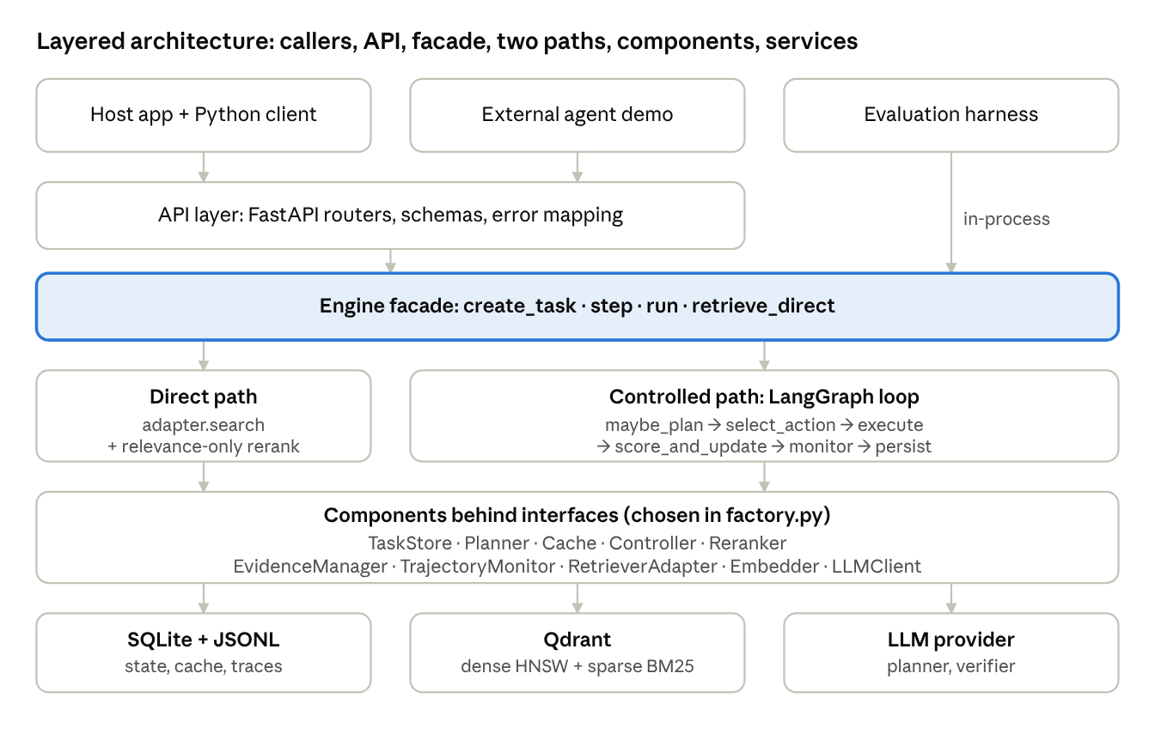
layered architecture · 6 layers, 2 execution paths
The evaluation harness calls the facade in-process so that experiments and the API run identical code. Only the harness bypasses HTTP.

2.2 Component decomposition
Component | Package | Responsibility | Interface (key methods) | Owner
API layer | engine/api | HTTP routing, validation, error mapping | FastAPI routers | Vishal
Engine facade | engine/core.py | Entry point for both paths; builds the graph | create_task, step, run, retrieve_direct | Samay (direct path: Kabir)
Factory | engine/factory.py | Instantiates concrete components from config | build(config) | Samay
TaskStore | engine/state | Persist and load S_t with optimistic locking | create, load, save | Samay
Planner | engine/planner | Decompose, rewrite, split; validate; fall back | plan(state, mode) | Vishal
Cache | engine/cache | Task-local result cache and REUSE gate | lookup, put | Kabir
Controller | engine/controller | Preconditions, utility scoring, action choice | select_action(state, cache_hit) | Samay
RetrieverAdapter | engine/retrieval | Dense, sparse, hybrid search on Qdrant | search, health | Kabir
Embedder | engine/embeddings | Query and passage embeddings, LRU cache | embed_queries, embed_passages | Kabir
Reranker | engine/rerank | Cross-encoder plus state-aware MMR selection | rerank(query, candidates, state) | Samay
EvidenceManager | engine/evidence | Accept evidence, resolve gaps, evidence gain | update(state, scored, step) | Samay
TrajectoryMonitor | engine/monitor | Stagnation, gap advancement, stop checks | observe(state, decision, update), advance(state) | Samay
Trace writer | engine/monitor/trace.py, logging.py | TraceStep records and structured event log for the engine and all baselines | TraceStep / event schema (OBSERVABILITY) | Vishal
LLMClient | engine/llm | Providers, structured output, cache, caps, cost | structured, text | Vishal
Client | client/ | Typed HTTP client for hosts and agents | one method per endpoint | Vishal
Evaluation | eval/, baselines/ | Datasets, baselines, runner, metrics, stats, reports | run_task(task, ctx) | Vishal
Ingestion | data/ | Download, chunk, embed, index, gold map, split | python -m data.ingest | Kabir

2.3 Dependency rules
- A component may import only engine.state.models, engine.config, and other components' interfaces.py.
- Only engine/factory.py imports concrete component classes.
- Only engine/llm imports provider SDKs; only engine/embeddings loads the embedding model.
- examples/ and host applications import only client and client.models.
- An automated test parses imports and fails the build if any rule is broken.

2.4 Key design decisions
ADR | Decision | Rationale | Status
ADR-001 | BGE-base embeddings, 384-token sentence-aware chunks, BM25 sparse, versioned collection names | Good quality on CPU; one embedder for all similarity signals | Proposed
ADR-002 | Synchronous core; SQLite TaskStore is the only persisted state; LangGraph without checkpointer | One source of truth; simpler debugging | Accepted
ADR-003 | Checksummed MultiHop-RAG release; stratified 70/30 split, fixed seed | Reproducibility; no test leakage | Proposed
ADR-004 | Planner and generator models chosen after a 50-task pilot | Reliability of JSON output and cost | Proposed
ADR-005 | Pretrained BGE cross-encoder, relevance mapped to [0,1] | No training in scope; strong on news passages | Proposed
ADR-009 | State contract amendments: per-iteration scratch, current-gap fields derived from the gap, state and cache committed atomically | Makes the loop implementable without ownership conflicts | Proposed
ADR-010 | API request limits read from configuration (api.*, retrieval.default_k, retrieval.max_k) | No literal limits; respects the reranker input cap | Proposed
ADR-011 | Recorded deviations from the approved proposal (Windows-only setup; no LangGraph checkpointer; gain signal; planner inputs; cache storage) | Supervisor approval of design changes | Proposed (supervisor)
— | Deterministic rule-plus-utility controller rather than an LLM policy | Transparency, injection resistance, no training | Fixed by proposal

2.5 Package structure
engine/
config.py core.py factory.py errors.py
state/ models.py store.py serialization.py invariants.py interfaces.py
graph/ graph.py nodes.py
planner/ planner.py validator.py entities.py prompts/{init,rewrite,split}.j2
cache/ task_cache.py normalize.py
controller/ policy.py signals.py
retrieval/ qdrant_adapter.py
embeddings/ st_embedder.py
rerank/ cross_encoder.py state_aware.py
evidence/ manager.py
monitor/ monitor.py trace.py logging.py
llm/ client.py cache.py providers/{anthropic,openai_compatible,fake}.py
api/ app.py routers.py schemas.py
client/ retrieval_client.py models.py
baselines/ dense_oneshot.py hybrid_oneshot.py fixed_iteration.py
eval/ datasets/ run.py generator.py metrics.py stats.py report.py
data/ download.py ingest.py
examples/ langgraph_agent/

3. Behavioural design

3.1 One controlled step
Each call to Engine.step runs one iteration; Engine.run repeats iterations until the task stops. The Engine (through LangGraph nodes) is the only caller of components; components never call each other.
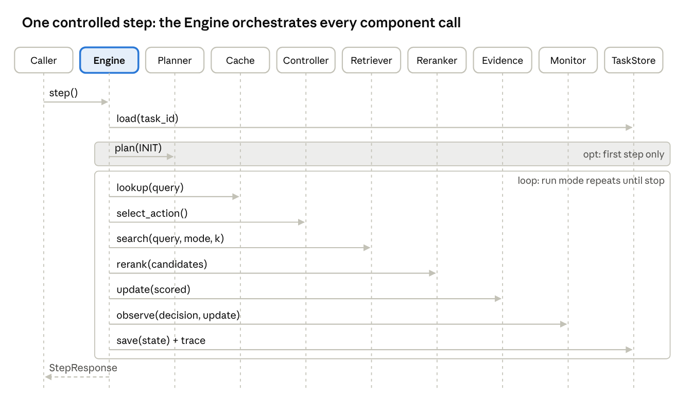
sequence diagram · one controlled step, 10 participants
If the chosen action produces no candidates (TRANSFORM or STOP), the rerank and evidence calls are skipped. A failure anywhere before save aborts the iteration, so stored state stays at the last completed step.

3.2 LangGraph node design
Nodes are plain functions node(graph_state, ctx) -> partial update; ctx carries component instances from the factory. Per-iteration data (cache hit, candidates, scores, queued cache entries) travels in a transient scratch that is never persisted. The graph is compiled without a persistent checkpointer (ADR-002).
Node | Behaviour | Fields written
maybe_plan | If needs_initial_plan: call Planner.plan(INIT), create gaps, then call TrajectoryMonitor.advance to set the current gap (the pending query and need type are read from that gap); else no-op | gaps, current gap ID, query history, plan events, LLM budget, needs_initial_plan
select_action | Cache.lookup for the pending query, then Controller.select_action | last decision
execute | Run the chosen action (Section 3.3); a REWRITE updates only the current gap's query and need type; a SPLIT supersedes the gap, creates its children and calls advance | retrieval history, seen IDs, budget counters; gaps for TRANSFORM
score_and_update | If candidates exist: rerank, then evidence update; queue a cache entry for fresh retrievals (committed by persist) | evidence, gap resolution, last result, last update, reranker counter
monitor | Stagnation bookkeeping, gap advancement, stop checks | stagnation, transforms, gain EMA, current gap, status, stop reason
persist | Increment budget.steps_used; save the state and the queued cache entries to TaskStore in one transaction; append trace record | budget.steps_used, version, updated time, cache entries
After persist, a conditional edge returns to maybe_plan while the task is active in run mode, and ends otherwise. recursion_limit is derived from max_steps as a safety net; the monitor is the real stop mechanism.

3.3 Action execution
Action | Backend call | Produces candidates | Budget effect
REUSE | None; cached candidates | Yes | steps + 1
DENSE | search(pending query, dense, default_k) | Yes | steps + 1, retrieval calls + 1
SPARSE_HYBRID | search(pending query, sparse if lexical else hybrid, default_k) | Yes | steps + 1, retrieval calls + 1
RERANK_EXPAND | Re-issue last query at depth + expand_step_k (≤ max_k); keep unseen only | Yes | steps + 1, retrieval calls + 1
TRANSFORM | Planner.plan(REWRITE or SPLIT) | No | steps + 1, LLM calls + attempts
STOP | None | No | steps + 1

3.4 State machines
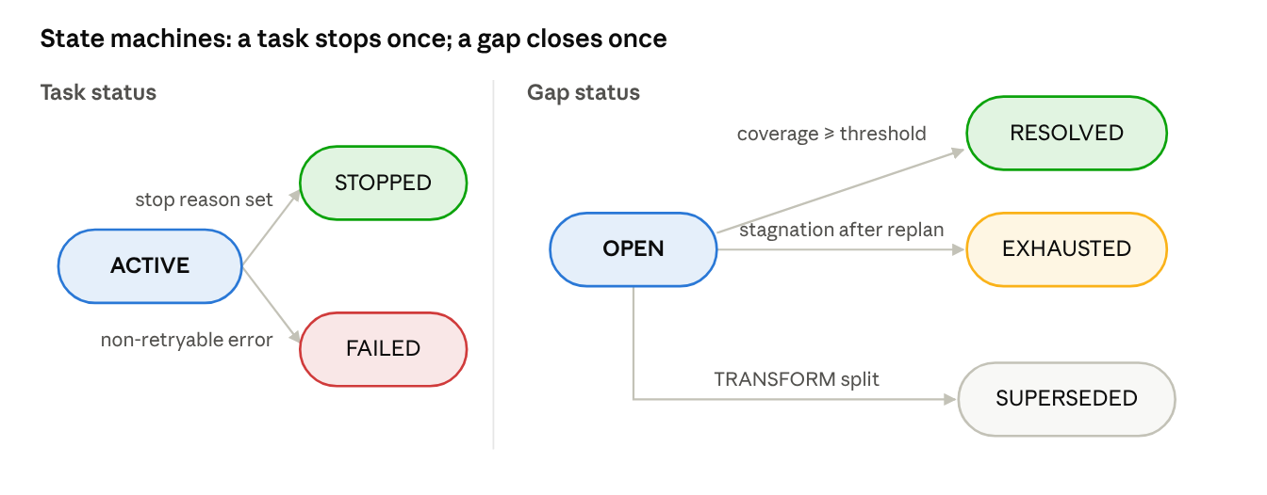
state machines · task status and gap status
A task is ACTIVE until the monitor or controller sets a stop reason (STOPPED) or a non-retryable error occurs (FAILED); both are terminal. A gap starts OPEN and closes exactly once. A SUPERSEDED parent counts as resolved when all its children are RESOLVED. The task stops with ALL_GAPS_RESOLVED when no gap is OPEN and every root gap is resolved, and with STAGNATION when no gap is OPEN otherwise.

4. Data design
All shared data are Pydantic v2 models in engine/state/models.py; this section is their data dictionary. Vector fields are persisted internally but excluded from API responses, traces and bundles.

4.1 Enumerations
Enum | Values
NeedType | semantic, lexical, mixed
RetrievalMode | dense, sparse, hybrid
Action | REUSE, DENSE, SPARSE_HYBRID, TRANSFORM, RERANK_EXPAND, STOP
GapStatus | open, resolved, superseded, exhausted
TaskStatus | active, stopped, failed
StopReason | ALL_GAPS_RESOLVED, STAGNATION, LOW_MARGINAL_UTILITY, MAX_STEPS, MAX_RETRIEVAL_CALLS, MAX_LLM_CALLS, MAX_TOKENS, ONE_SHOT_COMPLETE, FIXED_ITERATIONS_COMPLETE, ERROR
PlanMode / PlanStatus | init, rewrite, split / accepted, rejected, fallback

4.2 RetrievalState (S_t)
Field | Type | Meaning (S_t element)
schema_version, task_id, version, status, stop_reason | int, str, int, enum, enum? | Schema version, identity, optimistic-lock version, lifecycle (budget.steps_used is the only step counter)
goal | str | G, immutable
gaps | list[EvidenceGap] | Decomposed information needs
current_gap_id | str? | g_t (identifies the current gap)
current_subgoal, pending_query, current_need_type | str, str, NeedType (computed) | Derived from the current gap's description, query and need type; not stored
needs_initial_plan | bool | True until INIT planning runs
evidence | list[EvidenceItem] | E_t
query_history | list[QueryRecord] | Q_t, append-only
retrieval_history | list[RetrievalRecord] | R_t, append-only
budget | Budget | B_t
seen_candidate_ids, last_result | list, LastResult? | Support for RERANK_EXPAND (depth = last_result.depth) and repeat detection
stagnation_count, transforms_in_streak, action_gain_ema | int, int, dict | Monitor bookkeeping
last_decision, last_update, plan_events | ActionDecision?, EvidenceUpdate?, list | Last step's decision, evidence result, planner log
created_at, updated_at | datetime | Timestamps

4.3 Supporting models
Model | Key fields
Budget | max_steps, max_retrieval_calls, max_llm_calls, max_tokens; *_used counters; reranker_calls_used; pressure() = max utilisation ratio in [0,1]
EvidenceGap | gap_id, description, query, need_type, status, parent_gap_id, resolved_by, created_at_step, closed_at_step
Candidate | chunk_id, doc_id, text, retrieval_score, rank, mode, metadata, vector
ScoredCandidate | candidate, relevance, gap_coverage, novelty, redundancy, final_score, covered_gap_id
EvidenceItem | evidence_id (= chunk_id), doc_id, text, summary, relevance, novelty, final_score, source_action, query, metadata, added_at_step, supports_gap_ids, pinned, vector
QueryRecord / RetrievalRecord | step, gap, query, need type, source / step, action, mode, query, k, candidate IDs, new IDs, cache_hit, latency
PlanLLMOutput / PlanResult / PlanOutcome | subgoals, referenced_entities, rationale (what the LLM returns; no mode) / mode, subgoals (description, query, need_type), referenced_entities, rationale / result, events, llm_calls, tokens
ActionDecision | action, eligible, scores {G, C, R, L, U} per action, stop_reason, plan_mode (TRANSFORM only), rule
CacheEntry / CacheHit | task_id, normalized_query, query_vector, need_type, mode, candidates, accepted_ids / entry, similarity, match
EvidenceUpdate | accepted, rejected {id: code}, evicted, resolved_gap_ids, gap_resolutions, item_changes, evidence_gain
EvidenceBundle | task_id, system, goal, evidence (by score), gaps, stop_reason, trace_summary
TraceStep | run/task/system IDs, step, action, rule, eligible set, utility scores, query, mode, k, cache hit, candidate/accepted/rejected/evicted IDs, resolved gaps, evidence gain, plan events, stage latencies, LLM calls, tokens, budget after, stop reason, timestamp

4.4 Field-ownership matrix
Field(s) | Only writer
task_id, goal, created_at, budget maxima | TaskStore.create
version, updated_at, budget.steps_used | persist node / TaskStore.save
gap creation and supersession, a REWRITE's gap query and need type, query history, plan events, needs_initial_plan | Planner (via maybe_plan or TRANSFORM)
evidence, gap resolution | EvidenceManager
gap exhaustion, gap advancement (current gap ID), stagnation, transforms, gain EMA, status, stop reason | TrajectoryMonitor
last_decision | select_action node
retrieval history, seen IDs | execute node
last_result, last_update | score_and_update node
budget usage counters | the node that consumed the resource
status = failed, stop reason = ERROR (non-retryable error) | Engine facade, outside the graph

4.5 Invariants
- Budget usage never exceeds its cap (tokens may exceed by at most one call, then MAX_TOKENS).
- Evidence IDs are unique; evidence count ≤ evidence.max_items.
- Query, retrieval and plan histories are append-only.
- A RESOLVED gap's resolved_by names a pinned evidence item.
- status = active if and only if stop_reason is empty; stop_reason is set once.
- While active and planned, the current gap is OPEN.
- Open plus resolved gaps ≤ planner.max_gaps.
- version increases by exactly 1 per save.

4.6 SQLite schema
PRAGMA journal_mode = WAL;
CREATE TABLE tasks (
task_id TEXT PRIMARY KEY,
version INTEGER NOT NULL,
status TEXT NOT NULL CHECK (status IN ('active','stopped','failed')),
state_json TEXT NOT NULL, -- RetrievalState incl. vectors
created_at TEXT NOT NULL,
updated_at TEXT NOT NULL
);
CREATE TABLE cache_entries (
task_id TEXT NOT NULL REFERENCES tasks(task_id),
entry_id TEXT NOT NULL,
normalized_query TEXT NOT NULL,
mode TEXT NOT NULL,
entry_json TEXT NOT NULL, -- CacheEntry incl. candidate vectors
created_at_step INTEGER NOT NULL,
PRIMARY KEY (task_id, entry_id)
);
CREATE INDEX idx_cache_task_query ON cache_entries(task_id, normalized_query);
-- separate file: llm_cache.sqlite3
CREATE TABLE llm_cache (
key TEXT PRIMARY KEY, -- sha256 of provider, model, role, params, messages, schema, namespace
response_json TEXT NOT NULL,
usage_json TEXT NOT NULL,
created_at TEXT NOT NULL
);
save(state, expected_version, cache_entries) runs UPDATE tasks SET …, version = version + 1 WHERE task_id = ? AND version = ? and writes the iteration's queued cache entries in the same transaction; zero rows updated raises TaskConflict (HTTP 409) and nothing is written.

4.7 Qdrant collection
Item | Design
Collection | <dataset>_v<N>, for example multihop_v1; new N for any index-defining change
Dense vector | Named dense, 768 dimensions, cosine distance, HNSW m = 16, ef_construct = 128
Sparse vector | Named sparse, BM25 encoding (IDF handling as verified for the pinned version)
Point ID | UUIDv5(fixed namespace, chunk_id); chunk_id itself = first 16 hex of sha1(doc_id:char_start)
Payload | chunk_id, doc_id, text, title, source, url, published_at, char_start, char_end, dataset
Payload indexes | Keyword on chunk_id and doc_id

4.8 Run artefacts
eval/runs/<YYYYMMDD-HHMMSS>_<experiment>_<git7>/
manifest.json config.resolved.yaml events.jsonl
b<B>/traces/<task_id>.jsonl b<B>/bundles/<task_id>.json
b<B>/answers.jsonl b<B>/per_task.csv b<B>/metrics.json
report/

5. Component design
Each subsection gives the component's responsibility, algorithm and failure behaviour. Configuration keys are named in code; defaults live in configs/base.yaml.

5.1 Query planner (FR4)
Modes. INIT at task start creates 1 to planner.max_subgoals gaps. REWRITE replaces the current gap's query. SPLIT supersedes the current gap with 2 to 3 child gaps; it is used when the gap already has 2 or more failed queries and the gap cap allows.
Inputs. Goal; current gap and its previous queries; other open gaps; up to planner.max_evidence_summaries evidence summaries (deterministic 300-character truncations), wrapped as untrusted evidence.
Validation order. SCHEMA → COUNT → EMPTY_OR_DUPLICATE → UNGROUNDED_ENTITY (fuzzy match ≥ planner.entity_match_threshold against goal, gaps and summaries) → UNDECLARED_ENTITY (deterministic extractor finds a span missing from referenced_entities).
for attempt in 1..max_attempts (2):
result = llm.structured("planner", prompt(mode, attempt, last_reason), PlanLLMOutput)
if transport failure after LLM-client retries: log REJECTED(LLM_ERROR); continue
if validate(result): log ACCEPTED(attempt); return result
log REJECTED(attempt, reason)
log FALLBACK
return fallback(mode) # INIT: one gap = goal; REWRITE/SPLIT: gap description, else goal
Fallback need type uses a heuristic: lexical for short text with an entity, year, ID or quoted string; semantic for why/how/explain questions with no entity; mixed otherwise.

5.2 Task-local cache (FR5)
Lookup filters by task_id in SQL, then tries an exact normalised match, then the best cosine similarity ≥ cache.similarity_threshold. A hit is usable only if its mode serves the need: dense serves semantic and mixed, sparse serves lexical, hybrid serves all. Entries for every fresh retrieval are queued during the iteration and committed with the state in the same TaskStore.save transaction; an entry with the same query and mode is replaced; at most cache.max_entries_per_task entries, oldest non-exact evicted first. REUSE sends the cached candidates through normal reranking (against the current pending query) and evidence acceptance.

5.3 Controller (FR6)
Selection procedure.
1. steps exhausted -> STOP(MAX_STEPS)
2. E = actions whose preconditions hold
3. retrieval calls exhausted: drop DENSE, SPARSE_HYBRID, RERANK_EXPAND, TRANSFORM
E empty -> STOP(MAX_RETRIEVAL_CALLS)
4. E empty -> STOP(MAX_LLM_CALLS or STAGNATION)
5. adaptive actions disabled -> fixed policy
6. score each a in E: U(a) = alpha*G - beta*C - gamma*R - delta*L
7. a* = argmax U; ties: REUSE > SPARSE_HYBRID > DENSE > RERANK_EXPAND > TRANSFORM
8. U(a*) < min_utility and >= 1 retrieval done -> STOP(LOW_MARGINAL_UTILITY)
9. a* = TRANSFORM: set plan_mode (REWRITE or SPLIT)
10. return a*
Preconditions. REUSE needs a cache hit. DENSE and SPARSE_HYBRID need retrieval budget and must not repeat the same query in the same mode; the non-preferred mode becomes eligible after stagnation or once the preferred mode has been tried (strategy switch). RERANK_EXPAND needs a last result for the current gap, depth below retrieval.max_k, and at least one top relevance inside controller.ambiguous_band. TRANSFORM needs LLM budget, a remaining transform in the streak, and stagnation or all retrieval actions blocked.
Utility. Weights are non-negative and sum to 1.
U(a \mid S_t) = \alpha\,G_t(a) - \beta\,C_t(a) - \gamma\,R_t(a) - \delta\,L_t(a), \qquad \alpha+\beta+\gamma+\delta = 1
For DENSE and SPARSE_HYBRID the expected gain combines gap alignment, the action's recent gain (exponential moving average) and its fit to the need type:
G_t(a) = s_{gap}\,\max_{g \in O}\cos(q, e_g) + s_{ema}\,\overline{gain}(a) + s_{type}\,\mathrm{match}(a, \nu)
Signal | REUSE | DENSE / SPARSE_HYBRID | RERANK_EXPAND | TRANSFORM
G (gain) | hit similarity × share of cached candidates not yet in E_t | formula above | 0.5 × ambiguity + 0.5 × recent gain | min(1, stagnation / patience)
C (cost) | cost units / max units × (0.5 + 0.5 × budget pressure) | same | same | same
R (redundancy) | 0 | max cosine to earlier queries in the same mode | share of last results already in E_t | 0
L (latency) | profiled latency / max profiled latency | same | same | same
Cost units default to REUSE 0, DENSE 1, SPARSE_HYBRID 1, RERANK_EXPAND 2, TRANSFORM 2. Latencies come from configs/latency_profile.yaml when profiled, else from controller.default_latency_ms.
Worked example (unit test). With equal weights, budget pressure 0.5, gap alignment 0.8, and a stagnant earlier dense query: U(DENSE) = −0.181, U(SPARSE_HYBRID) = 0.069, U(TRANSFORM) = −0.3125, so the controller switches strategy to SPARSE_HYBRID.

5.4 Retriever adapter and embedder (FR1, FR3)
QdrantAdapter.search(query, mode, k) embeds the query (dense) or encodes it (sparse), and for hybrid issues one Query API request with dense and sparse prefetch of retrieval.hybrid_prefetch_k each, fused by RRF. It returns candidates with payload and dense vectors. Timeouts and connection errors raise BackendError; partial results are never returned. Scores are not compared across modes. The embedder applies the model's query or passage prefix, normalises vectors and keeps an LRU cache.

5.5 State-aware reranker (FR7)
Relevance is the cross-encoder score of (pending query, chunk), mapped to [0,1]. Gap coverage is the best cosine to an open gap description. Novelty is one minus the best cosine to accepted evidence. Selection is greedy (MMR-style), penalising redundancy with candidates already selected:
\mathrm{final}(c) = w_{rel}\,\mathrm{rel}(c) + w_{gap}\,\mathrm{cov}(c) + w_{nov}\,\mathrm{nov}(c) - w_{red}\,\max_{s \in S}\cos(c, s)
Output is the top rerank.top_n_output (10). With state-awareness disabled, and in all baselines, final = relevance.

5.6 Evidence manager (FR8)
Candidates are processed in final-score order and rejected as DUPLICATE, LOW_RELEVANCE, LOW_NOVELTY, STEP_CAP or CAP_REACHED; otherwise accepted with a deterministic summary. When evidence is full, the lowest-scoring unpinned item is evicted. A gap is resolved by the accepted item with the highest coverage if it reaches evidence.gap_coverage_threshold; optional LLM verification handles near-threshold items within the LLM budget. Resolving items are pinned.
\mathrm{gain}_t = w_{res}\,\frac{|\text{newly resolved gaps}|}{\max(1, |\text{open gaps at step start}|)} + w_{q}\,\frac{1}{|A_t|}\sum_{e \in A_t}\mathrm{rel}(e)\,\mathrm{nov}(e)

5.7 Trajectory monitor (FR8)
After each step, in order: (1) update gain EMA and stagnation from evidence gain; count TRANSFORM steps in the streak; (2) propagate SUPERSEDED parents; (3) advance to the next OPEN gap when the current one is resolved, or mark it EXHAUSTED after monitor.stagnation_patience stagnant steps once the transform allowance is used; (4) check stops in order: all root gaps resolved → ALL_GAPS_RESOLVED; no open gaps → STAGNATION; steps → MAX_STEPS; tokens → MAX_TOKENS; the controller's STOP → its reason.

5.8 LLM client (FR4, NFR-P4/P5)
Roles planner, verifier and generator; providers anthropic, openai_compatible (hosted OpenAI-style APIs and local servers such as Ollama or LM Studio) and fake for tests. Structured output = schema in the system message, fence stripping, JSON parse, Pydantic validation; failure raises LLMOutputError. Transport errors are retried with exponential backoff. A SQLite response cache keys on a hash of provider, model, role, parameters, messages, schema and namespace. Budget counts logical calls, cached or not, so behaviour does not depend on cache state. Per-run caps on calls and USD cost abort a run cleanly.

5.9 Task store (FR2, NFR-R1/R4)
SQLite in WAL mode; one connection per worker thread. create validates and inserts S_0; load deserialises including vectors; save performs the version-checked update from Section 4.6. Because save happens only in the persist node, any exception earlier in an iteration leaves the stored state unchanged.

6. Interface design
The REST API is versioned under /v1, uses JSON bodies, and is generated from the same Pydantic models the engine uses internally, so schemas cannot drift. OpenAPI documentation is served at /docs.

6.1 Endpoints
Method and path | Purpose | Request | Success response
GET /v1/health | Liveness and backend check | — | 200 status, Qdrant reachable, version, config hash
POST /v1/tasks | Create task, persist S_0 | goal (length api.goal_min_chars–api.goal_max_chars), optional budget, optional task_id | 201 task_id and state
POST /v1/tasks/{id}/step | Run one iteration | — | 200 step, action, done, stop reason, new evidence, open gaps, budget
POST /v1/tasks/{id}/run | Iterate until stop | — | 200 EvidenceBundle
GET /v1/tasks/{id}/result | Bundle of a stopped task | — | 200 EvidenceBundle
GET /v1/tasks/{id}/state | Full state for debugging | — | 200 RetrievalState (no vectors)
GET /v1/tasks/{id}/trace | Trajectory | — | 200 list of TraceStep
POST /v1/retrieve/direct | Controller-OFF retrieval | query (≤ api.query_max_chars), mode (dense, sparse, hybrid), k (default retrieval.default_k, at most retrieval.max_k), rerank flag | 200 candidates, optional relevances, latency
Omitted budget fields default to budget_defaults.*. /run is bounded by api.run_timeout_s; on timeout the task keeps its last completed step and the caller may continue with /step.

6.2 Error mapping
Every error has the body {"error": {"code", "message", "task_id"}}.
Internal exception | HTTP | Code
TaskNotFound | 404 | TASK_NOT_FOUND
Duplicate task_id | 409 | TASK_EXISTS
TaskNotActive (step/run on stopped task, result on active task) | 409 | TASK_NOT_ACTIVE
TaskConflict (concurrent step, version mismatch) | 409 | TASK_CONFLICT
Request validation failure | 422 | VALIDATION_ERROR
LLMBudgetExceeded (per-run cap) | 429 | RUN_BUDGET_EXCEEDED
Unhandled exception | 500 | INTERNAL_ERROR
LLMError | 502 | LLM_ERROR
BackendError | 503 | BACKEND_ERROR
Run timeout | 504 | RUN_TIMEOUT

6.3 Python client
client.RetrievalClient(base_url) wraps each endpoint with a typed method (create_task, step, run, get_result, get_state, get_trace, retrieve_direct), uses httpx with api.client_timeout_s, and raises mapped exceptions (TaskNotFound, TaskNotActive, BackendUnavailable, and so on). It imports models from the engine and re-exports them as client.models, so hosts import only the client.
client = RetrievalClient("http://127.0.0.1:8000")
task = client.create_task(goal="...", budget=BudgetRequest(max_retrieval_calls=4))
bundle = client.run(task.task_id) # or loop client.step(task.task_id)
hits = client.retrieve_direct("...", mode=RetrievalMode.HYBRID, k=10)

6.4 Internal component interfaces
Interface | Methods
TaskStore | create(goal, budget), load(task_id), save(state, expected_version, cache_entries)
Planner | plan(state, mode) -> PlanOutcome
Cache | lookup(task_id, query, need_type) -> CacheHit or None, put(entry)
Controller | select_action(state, cache_hit) -> ActionDecision
RetrieverAdapter | search(query, mode, k, filters, with_vectors), health()
Embedder | embed_queries(texts), embed_passages(texts)
Reranker | rerank(query, candidates, state) -> list[ScoredCandidate]; state=None gives relevance-only mode
EvidenceManager | update(state, scored, step) -> EvidenceUpdate
TrajectoryMonitor | observe(state, decision, update) -> MonitorVerdict, advance(state) -> AdvanceResult
LLMClient | structured(role, messages, schema), text(role, messages)

7. Evaluation subsystem design
The evaluation subsystem makes comparisons fair by construction: every system runs through the same runner, index, models, generator and trace schema, and differs only in control logic.

7.1 Baselines
System | Algorithm | Retrieval calls | LLM use | Stop reason
dense_oneshot | Direct dense search, k = retrieval.default_k; relevance-only rerank; top 10 | 1 | None | ONE_SHOT_COMPLETE
hybrid_oneshot | Same with hybrid mode | 1 | None | ONE_SHOT_COMPLETE
fixed_iteration | Same planner INIT; for hop 1..N (N = B): query = next subgoal or planner rewrite; hybrid search; relevance-only rerank; accept by relevance threshold, no novelty or gap logic; no cache, no early stop | Exactly N | INIT + rewrites | FIXED_ITERATIONS_COMPLETE
controller_on | Full engine via Engine.run | ≤ B (equal budget) | Planner, optional verifier | Engine's reason
adaptive_rag_router (stretch) | Complexity classifier routes to no retrieval, one-shot or fixed-iteration | Varies | Classifier | Varies
Every system returns at most rerank.top_n_output evidence items, so the generator sees the same maximum context.

7.2 Experiment runner
eval/run.py --config configs/experiments/<name>.yaml:
- Resolve config (base + experiment); refuse a test-split run unless the frozen-config tag is present and the tree is clean.
- Load tasks through the common Task interface (dataset, split, optional dev subset).
- For each value B in experiment.retrieval_budgets, run all tasks with a thread pool of eval.max_workers, writing traces and bundles.
- Generate answers with the shared generator (temperature 0, fixed prompt, context capped at eval.generator_max_context_tokens).
- Compute per-task and aggregate metrics; write the manifest last, marking the run reportable only if all checks pass.

7.3 Metrics
Gold evidence is a list of chunk-ID groups; a group is hit if any member is retrieved. Null queries are excluded from retrieval and evidence metrics.
Group | Metrics
Retrieval quality | Recall@k, Hit@k, MRR, NDCG@k for k in {1, 3, 5, 10}; before vs after reranking
Evidence quality | Complete-evidence recall (CER), partial coverage, trajectory coverage, repeated-document rate, redundant-evidence rate, evidence gain per retrieval
Task performance | MultiHop-RAG official accuracy (per question type); HotpotQA EM and F1; curated rubric by two reviewers
Efficiency and trajectory | Retrieval calls per task and per correct answer, cache-hit rate, LLM calls, tokens, cost, latency (median, p90), zero-gain retrievals, premature stops, over-retrieval, stagnation episodes
\mathrm{CER} = \frac{1}{|T|}\sum_{t \in T} \mathbf{1}\left[\forall\, g \in G_t:\; g \cap B_t \neq \emptyset\right]
where G_t is task t's gold groups and B_t its final bundle.

7.4 Statistics
Paired bootstrap with eval.bootstrap_resamples (10,000) resamples gives 95% confidence intervals for per-task metric differences. Exact McNemar tests compare binary outcomes (correct, complete evidence). Final LLM-dependent test runs repeat 3 times with separate LLM-cache namespaces; results report mean and standard deviation across repeats.

7.5 Experiment plan
ID | Purpose | Systems | Data
E0 | Pipeline sanity | dense_oneshot | Dev subset
E1 | Equal-budget comparison, B = 2, 3, 4 (VQ1) | All four | Dev in FYP-I, test in FYP-II
E2 | Natural-policy comparison (VQ1) | All four | Dev, test
E3 | One-at-a-time ablations (VQ2) | controller_on variants | Dev, test
E4 | Weight and threshold sensitivity (VQ2) | controller_on | Dev
E5 | Generalisation (VQ3) | All four | HotpotQA sample
E6 | Representative agentic tasks (VQ3) | controller_on vs fixed_iteration | Curated benchmark

7.6 Calibration design
Calibration runs on the dev split only, in order: evidence thresholds; cache similarity threshold; then stagnation threshold, minimum utility and weights by grid search (weight simplex step 0.2, 56 combinations, on the dev subset; top 5 re-run on the full dev split). The objective is
J = \mathrm{CER} - \lambda \cdot \frac{\overline{\text{retrieval calls}}}{\text{max retrieval calls}}, \qquad \lambda = 0.1
The chosen values are recorded in ADR-006, frozen, and tagged before any test-split run.

8. Deployment, configuration, error handling and security

8.1 Deployment view
Node | Runs | Port / location
Developer machine (Windows 10 or 11, 64-bit) | Engine (uvicorn), eval harness, ingestion, tests | 127.0.0.1:8000
Qdrant (native Windows binary) | qdrant.exe from the pinned Qdrant release, storage in var\qdrant_storage | 127.0.0.1:6333 (REST), 6334 (gRPC)
Local files | var/state.sqlite3, var/llm_cache.sqlite3, eval/runs/, data/processed/ | Repository working tree (gitignored)
LLM provider | Hosted API over HTTPS, or local OpenAI-compatible server | Provider URL or 127.0.0.1:11434
GitHub Actions (Windows runners) | Lint, type check, unit tests; integration tests against a qdrant.exe started in the job | CI
FYP-II packaging | Installable Python package (wheel) for the engine plus a Windows setup guide for the engine and Qdrant | —

8.2 Configuration design
Configuration is YAML, loaded into a Pydantic EngineConfig that rejects unknown keys. Precedence: configs/base.yaml (all defaults) → configs/experiments/<name>.yaml (overrides) → environment variables for secrets and machine-specific values only → CLI overrides for debugging, which mark a run non-reportable. Load-time validation checks weight sums, value ranges, default_k ≤ max_k, band ordering, and that every LLM role in use names a model. Index-defining and calibrated keys are frozen and change only through an ADR.

8.3 Error handling
Situation | Handling | Effect on state
Qdrant timeout or connection error | BackendError; iteration aborted | Unchanged (last completed step)
LLM transport error | Retry with exponential backoff; then LLMError | Unchanged
Invalid planner JSON or ungrounded plan | Counted as a rejected attempt; retry once; then deterministic fallback | Normal progress
Per-run LLM call or cost cap reached | LLMBudgetExceeded; run aborted; manifest records abort | Unchanged
Concurrent save | TaskConflict (409) | Unchanged
Non-retryable internal error | Task marked FAILED with stop reason ERROR | Terminal
Invalid configuration | ConfigError at start-up | Service does not start

8.4 Security design
- Secrets. Keys only in .env (gitignored); config holds environment-variable names; a secret scanner runs as a pre-commit hook; the LLM client redacts headers from errors.
- Exposure. Bind to localhost; an optional bearer-token middleware (ENGINE_API_TOKEN) for remote demos; Pydantic size limits on requests.
- Prompt injection. Retrieved text appears only in user messages, inside an <evidence untrusted="true"> block with escaped markup; system prompts state that evidence is data. The controller is deterministic, so injected text cannot choose actions. Planner output is schema- and grounding-validated; the verifier returns only a boolean. Residual risk: an entity injected into accepted evidence can steer a rewrite; traces make this inspectable.
- Dependencies. Pinned versions; monthly pip-audit; models only from repositories named in ADRs.

9. Test design

9.1 Test levels
Level | Scope | Dependencies | When it runs
Unit | One component through its interface | Fakes only (no network, no running Qdrant) | Every commit and PR (CI)
Integration | Qdrant adapter, ingestion, real embedder and cross-encoder | Local Qdrant (qdrant.exe), small models | PRs to main (CI Windows runner)
LLM | Planner and generator against a real model | Local or hosted LLM | Manually before milestones
End-to-end | Full engine on a fixture corpus | Qdrant, fixture corpus, fake or local LLM | Before milestones

9.2 Test doubles and fixtures
Fakes implement the real interfaces: FakeEmbedder (deterministic or explicitly mapped vectors), FakeRetriever (scripted results, injectable failures), FakeReranker, FakeLLMClient (scripted responses, recorded requests), FakeClock. Fixtures include a 30-chunk mini corpus with 5 two-hop questions (one exact-entity, one paraphrase-heavy, one null), valid, hallucinated and malformed planner outputs, and an injection document.

9.3 Key test cases
ID | Test | Verifies
T-01 | State invariants after every step over many synthetic tasks (property-based) | FR2.5, FR8.6
T-02 | Worked controller example reproduces −0.181 / 0.069 / −0.3125 | FR6.3
T-03 | One test per controller rule and precondition, including strategy switch | FR6.2, FR6.5
T-04 | Hallucinated entity rejected; two invalid outputs give exactly 2 calls then fallback | FR4.4, FR4.5
T-05 | Same query in two tasks never produces a cross-task cache hit | FR5.4
T-06 | Novel, gap-covering candidate outranks a near-duplicate with higher relevance (0.70 vs 0.644) | FR7.2
T-07 | Evidence acceptance codes, pinning, gap threshold, gain range | FR8.1–FR8.3
T-08 | Retriever fails on step 2: stored state equals step 1; API returns 503 | NFR-R1
T-09 | Golden action sequences and stop reasons on the fixture corpus | FR6, FR8 regression
T-10 | Metrics on hand-built traces (Recall@k, CER with groups, over-retrieval, premature stop) | FR10.3
T-11 | Import boundaries: no engine in examples; SDKs only in engine/llm; concrete classes only in factory | NFR-M2, FR11.3
T-12 | OpenAPI snapshot unchanged without an ADR | FR11.1
T-13 | Ingestion twice gives identical IDs, counts and gold map | FR1.1, FR1.5
T-14 | Base and experiment configs load; invalid weight sums rejected | NFR-M3
T-15 | Injection document stays inside the evidence block; out-of-schema planner action rejected | NFR-S4
Coverage targets: at least 85% of lines in controller, evidence, monitor, planner and cache; at least 70% overall.

10. Requirements-to-design traceability
SRS requirement | Design sections | Main components | Tests
FR1 Ingestion and indexing | 4.7, 5.4 | Ingestion, QdrantAdapter, Embedder | T-13
FR2 Task state | 4.2–4.6, 5.9 | RetrievalState, TaskStore | T-01
FR3 Two modes | 2.1, 3.3, 6.1 | Engine facade, API | API contract tests
FR4 Planning | 5.1 | Planner, validator | T-04
FR5 Cache and reuse | 5.2, 4.6 | TaskLocalCache | T-05
FR6 Action selection | 5.3 | Controller, signals | T-02, T-03
FR7 Reranking | 5.5 | StateAwareReranker | T-06
FR8 Evidence and stopping | 5.6, 5.7, 3.4 | EvidenceManager, TrajectoryMonitor | T-07, T-09
FR9 Bundle | 4.3 | EvidenceBundle | Schema tests
FR10 Tracing and metrics | 4.8, 7.2–7.4 | Trace writer, metrics, stats | T-10
FR11 Service, client, agent | 6.1–6.3 | API, RetrievalClient, agent demo | T-11, T-12
FR12 Benchmarks | 7.2 | Dataset loaders | Loader tests
NFR-R (reliability) | 5.9, 8.3 | TaskStore, persist node | T-08
NFR-S (security) | 8.4 | LLM client, prompt builder | T-15
NFR-M (maintainability) | 2.3, 8.2 | Factory, EngineConfig | T-11, T-14
NFR-X (reproducibility) | 4.8, 7.2, 7.6 | Runner, manifest | Reproducibility checklist

Open design items
Item | Resolved by | Owner
Exact Qdrant, LangGraph and fastembed call signatures for the pinned versions | Library verification scripts | Kabir, Samay
Cross-encoder output type (logits or probabilities) | ADR-005 evidence | Samay
Planner and generator models | ADR-004 pilot | Vishal
Calibrated weights and thresholds | ADR-006 | Samay

